Create Django project and app then add environment in this folder. cd to that folder.

# Create a virtual environment to isolate our package dependencies locally

python -m venv env

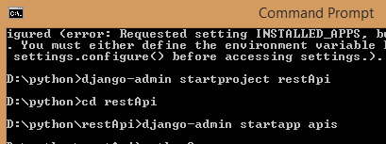



Activate this env, simply go up to **activate** file.

